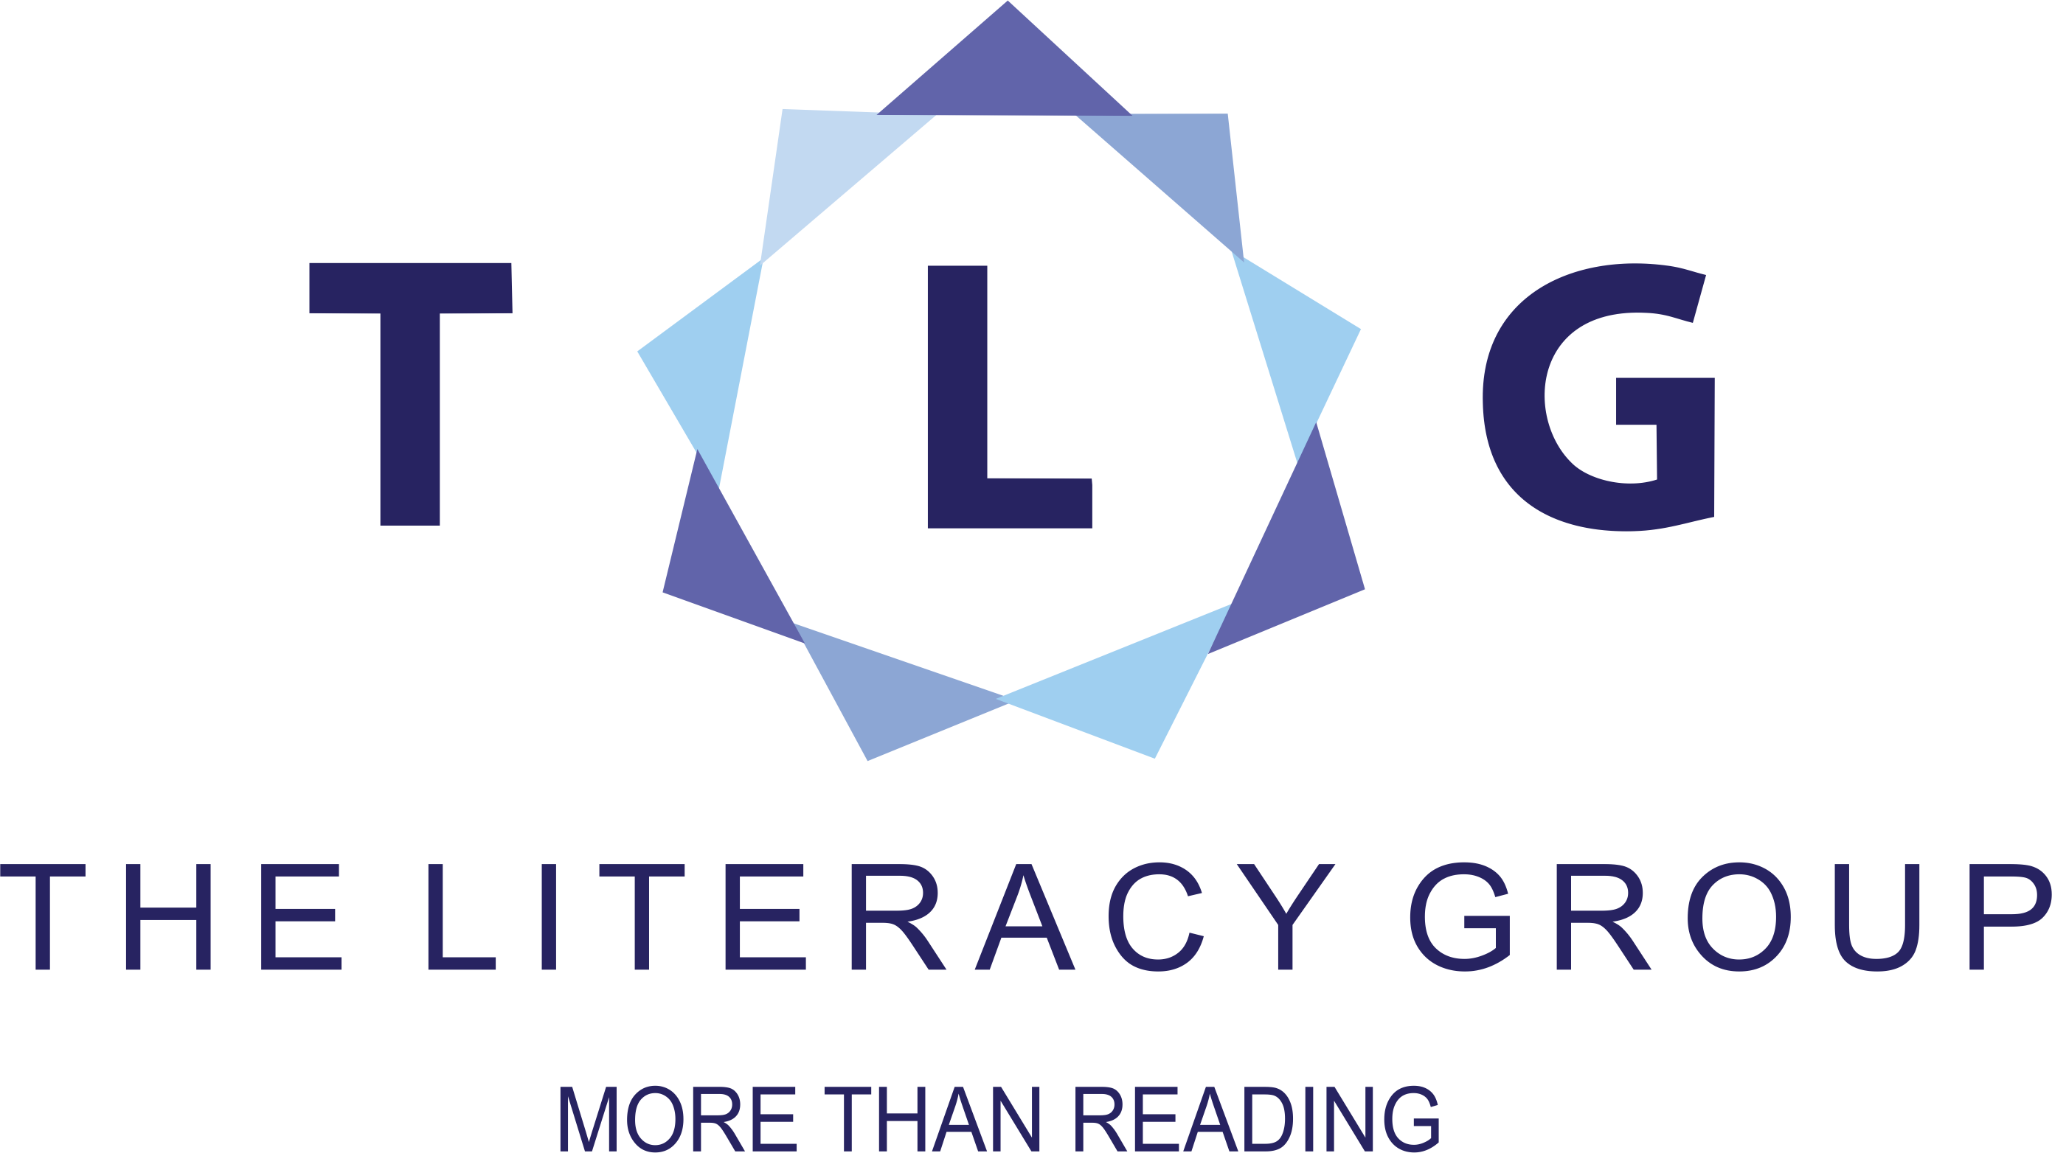
Complaints Procedure

Figure 1 Complaints Procedure
If a learner or volunteer feels they need to voice a complaint with regards to the services provided at The Literacy Group, they must abide by the following procedure. By taking part in the programs at The Literacy Group, the learner and volunteer agrees to this procedure.
No complaints can be received in complete confidence and TLG staff are obliged to inform all parties necessary to deal with the compliant.
- Consider if the issue be dealt with a private conversation with the Group Facilitator, the Program Coordinator or Office Administration.
- If the issue is one that prevents them from doing this, then they must contact the Program Manager.
- If the Program Manager cannot resolve the issue, then they will take the issue to the Executive. If the learner wishes to avoid speaking to The Program Manager, they have the right to contact the Executive Director.
- The Executive Director is responsible to resolve any issues that involve The Literacy Group of Waterloo Region.
- If any learner wishes to contact the Board President with regards to their complaint, they are free to do so and contact information can be found via the website.
The Literacy Group of Waterloo Region works to support any complaints with the necessary investigation involving all parties. The Literacy Group will work to resolve the complaint in the fairest, equal and prompt manner possible.

